Data Visualization Project 2

Name: Chew Yu Han

Student ID: 32022166

Tutorial: Tutorial 06

GitHub: [Click Here](https://github.com/chewyuhan/FIT3179-Asm2/tree/main/Assignment2)

Web-Visualization: [Click Here](https://chewyuhan.github.io/FIT3179-Asm2/Assignment2/)

Number of words: 898 Words

**Domain**

The domain that I have chosen is Global Terrorism Insight (2012-2022)

**Why**

Visualising global terrorism insights serves a crucial need in international security. By distilling complex data into visual insights, it empowers users to identify trends and hotspots and informs decision-making in counter-terrorism strategies. The visualisation addresses the specific domain of international security, promoting understanding, awareness, and data-driven approaches.

**What**

The Global Terrorism Index (GTI) delves into the repercussions of terrorism across 163 countries, collectively representing 99.7% of the global population.

To compile the GTI report, data was meticulously gathered from sources such as Terrorism Tracker by the Institute for Economics and Peace (IEP). The dataset that I found comes from three different authors with the same domain: Global Terrorism Index 2023 (Dee, 2023), Global Terrorism (Mexwell, 2023), and Global Terrorism Catalogue (KŁAPEYE FOUNDATION, 2023).

* Categorical
  + Region, Country, CATEGORY
* Ordered
  + Ordinal
    - Rank
  + Quantitative
    - Year, Score, Incidents, Fatalities, Injuries, Hostage, Terrorist_attacks

In the pre-processing phase, a series of cleaning procedures take place. This encompasses the elimination of redundant variables, aligning country names with the correct terminology from the map's topojson file, and the consolidation of both datasets into a comprehensive CSV file. Furthermore, regions are integrated into the dataset alongside their corresponding countries. Additionally, I employed power query in Excel to compute the sum of indicators and terrorist scores.

**Why and How**

Figure 1: (Entire Dashboard Visualisation) 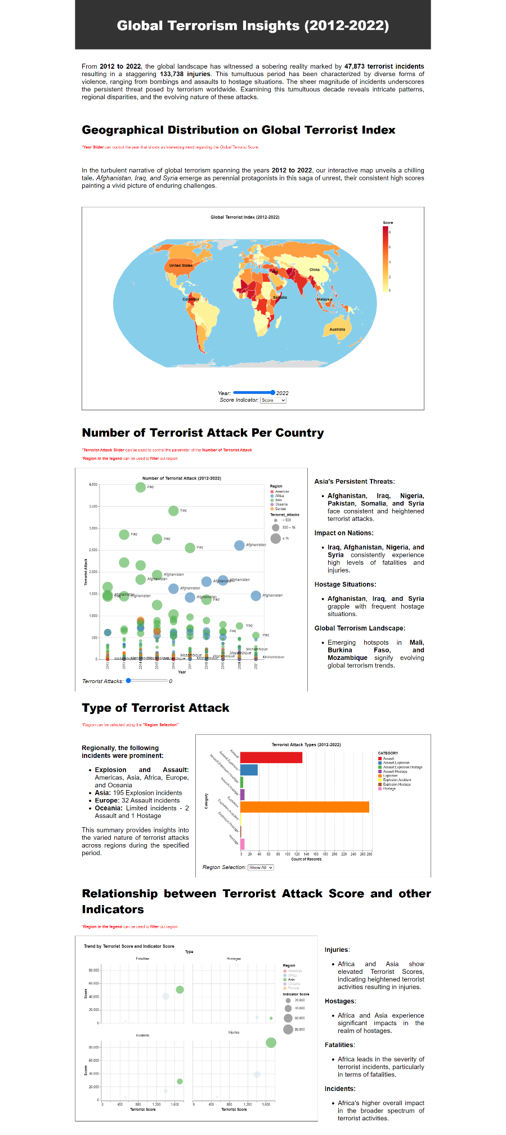

Figure 2: Global Terrorism Index Choropleth Map

**Why**

* Choropleth maps is used to visualize spatial patterns and variations. They provide an overview of how the selected indicator varies across geographical regions.

**How**

* Data Integration:
  + Integrates country boundaries (topojson) and Global Terrorism Index data (CSV).
* Filtering Data:
  + Filters data based on selected year.
  + Filters data based on selected indicators.
* Colour Encoding:
  + Applies a colour scale (#ffffb2 to #bd0026) based on selected indicator values.
* Tooltip Information:
  + Configures tooltips for country details on hover.
* Text Annotation:
  + Adds text annotations for specific countries (Iraq, Australia, US, etc).

Figure 3: Terrorist attack bubble plot

**Why**

* Highlights trends in global terrorist attacks from 2012 to 2022.

**How**

* Interactive Parameter:
  + Implements a range slider (Terrorist_attacks) for user-defined attack count filtering.
* Circle Marks for Regions:
  + Utilizes circular marks, color-coded by region.
* Circle Size Encoding:
  + Adjusts circle size based on attack counts with a threshold scale
* Opacity for Highlighting:
  + Uses opacity to highlight selected regions when interacting with the legend.
* Tooltip Information:
  + Provides detailed tooltips about each country, including attack counts, incidents, fatalities, injuries, and hostages.
* Text Annotations:
  + Adds text annotations for specific countries (Iraq, Afghanistan, Mozambique).

Figure 4:Terrorist Attack Type Bar Chart

**Why**

* Visualizes the distribution of terrorist attack types from 2012 to 2022.

**How**

* Interactive Parameter:
  + Implements a dropdown (Region_selection) for users to select specific regions.
* Bar Chart Layer:
  + Using a bar chart with attack categories on the y-axis and the count on the x-axis.
* Colour Encoding:
  + Color-codes bars based on attack categories using the "set1" colour scheme.
* Tooltip Information:
  + Tooltips provide details on attack categories and their respective counts.

Figure 5: Trend by Terrorist Score and Indicator Score

**Why**

* Illustrates trends in both terrorist scores and indicator scores, providing insights into their relationship.

**How**

* Interactive Highlighting:
  + Implements a legend-based multi-selection (region_highlight) for interactive highlighting of regions.
* Size Encoding:
  + Sizes circles based on the indicator score, using a linear scale ranging from 0 to 1000.
* Small Multiple:
  + Facets the plot by the "Type" field, organizing data into two columns for better readability.
* Tooltip Information:
  + Tooltips provide detailed information including region, terrorist score, and indicator score.
* Opacity for Highlighting:
  + Adjusts opacity to highlight selected regions when interacting with the legend.

**Design:**

The dashboard's design is meticulously crafted for user guidance, utilising a left-to-right, top-to-bottom progression. A responsive single-column layout ensures a straightforward reading experience. Figure 2's Choropleth Map strategically centres attention, maintaining an uninterrupted experience within a unified, invisible frame. Symmetrical division of containers enhances visual organisation.

**Colour:**

The global theme prioritises visual consistency with a unified colour palette extending to charts and headings. Distinct yet interconnected colours are chosen for different regions, using warm hues like reds and oranges to convey urgency in terrorism-related charts. Black text ensures readability, while strategic red text cues prompt users in areas like the year slider and region selection. Contrasting text colours against lighter backgrounds enhance overall legibility for a user-friendly experience. All the colour used are came from colour brewer where the colours are all colourblind friendly.

**Figure-Ground:**

In the design realm, graphical elements take centre stage, commanding attention through strategic emphasis. Generously sized and vibrant charts effortlessly draw focus, with designated elements standing out distinctly during filtering. A clear hierarchy is established through bold fonts for headings and smaller fonts for descriptive text, facilitating intuitive information consumption.

**Typography:**

The 'Arial' sans-serif typeface is deliberately selected for its clean, modern appearance and optimal readability. The text layout follows a structured approach with justified alignment, contributing to a professional aesthetic. Varying font sizes for headings and subheadings establish a clear hierarchy, enhancing visual organisation and readability.

**Storytelling:**

The dashboard adopts a narrative storytelling approach, leading viewers through a well-organised sequence. Chart progression follows a logical left-to-right, top-to-bottom flow, enhanced by Gestalt principles for grouping and clarity. Each section is introduced with descriptive text, guiding the reader through visualizations. Informative tooltips and interactive elements enrich user engagement, creating a comprehensive and engaging narrative about the global terrorist landscape in a succinct design.

**Reference** **List**

dee, dee. (2023). Global Terrorism Index 2023. Retrieved October 12, 2023, from Kaggle.com website: <https://www.kaggle.com/datasets/ddosad/global-terrorism-index-2023>

KŁAPEYE FOUNDATION. (2023). Global Terrorism Catalogue. Retrieved October 12, 2023, from Kaggle.com website: <https://www.kaggle.com/datasets/klapeyefoundation/global-terrorism>

mexwell. (2023). 💣 Global Terrorism. Retrieved October 12, 2023, from Kaggle.com website: <https://www.kaggle.com/datasets/mexwell/global-terrorism>

‌

‌

‌